**Pleasant Tours**

**User Guide**

|  |  |  |  |
| --- | --- | --- | --- |
| **Supervisor** | | Sir Abdul Ahad | |
| **Batch** | | 2209E | |
| **Group** | | Pleasant Tours | |
| **Serial No.** | **Enrollment Number** | | **Students** |
| 1. | 1413931 | | Mohammad Shayan |
| 2. | 1413916 | | HAFIZ MUHAMMAD SHUAIS |
| 3. | 1413909 | | ASGHAR ABBAS |
| 4. | 1413911 | | SYED KASHAN ABBAS NAQVI |
| 5. | 1416016 | | ABDULLAH |

**User Guide**

**“**PLEASANT TOURS**”** This Website is basically based on products of tourism. If you are passionate about travelling and want to buy travelling products, so this is just for you.

1. **Navigation Bar:**

This is on the top of every page.

User can navigate through different pages through this bar.

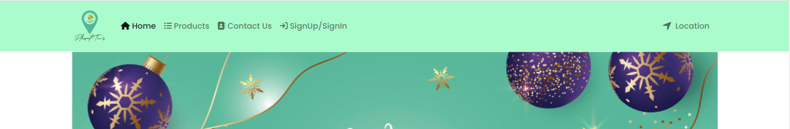

1. **Home page:**

This page contains about pleasant tours and trending products.

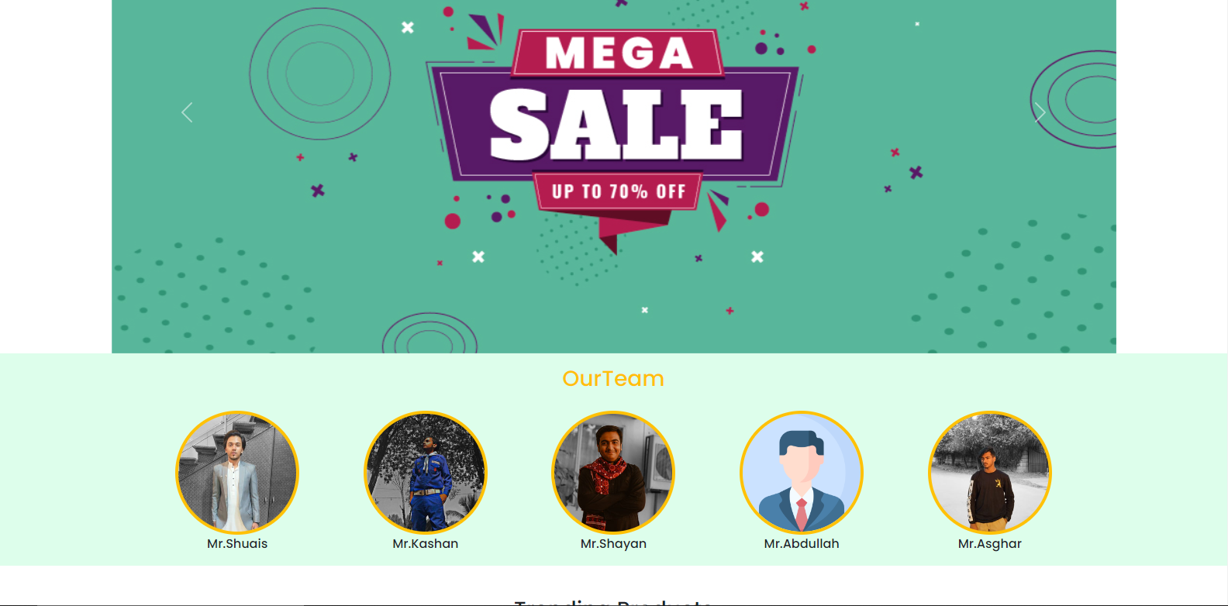

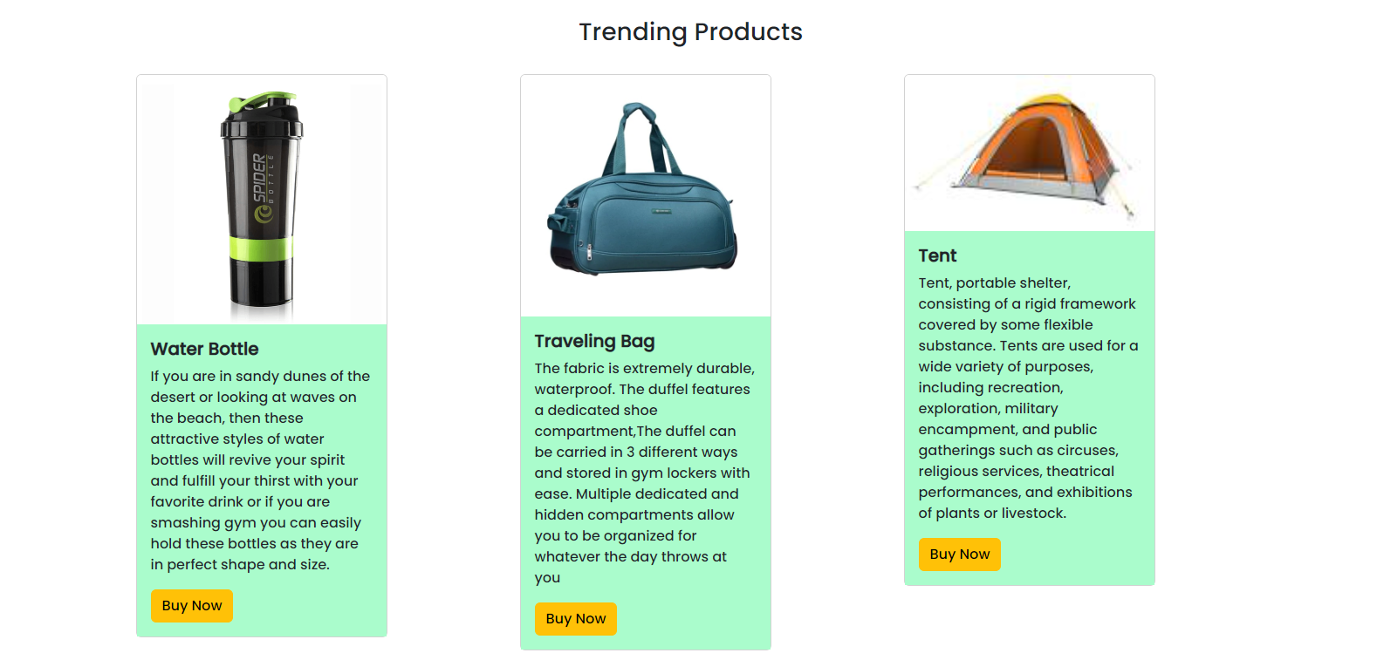

1. **Products page:**

This is the product page.

In this page user can grab their products through this.

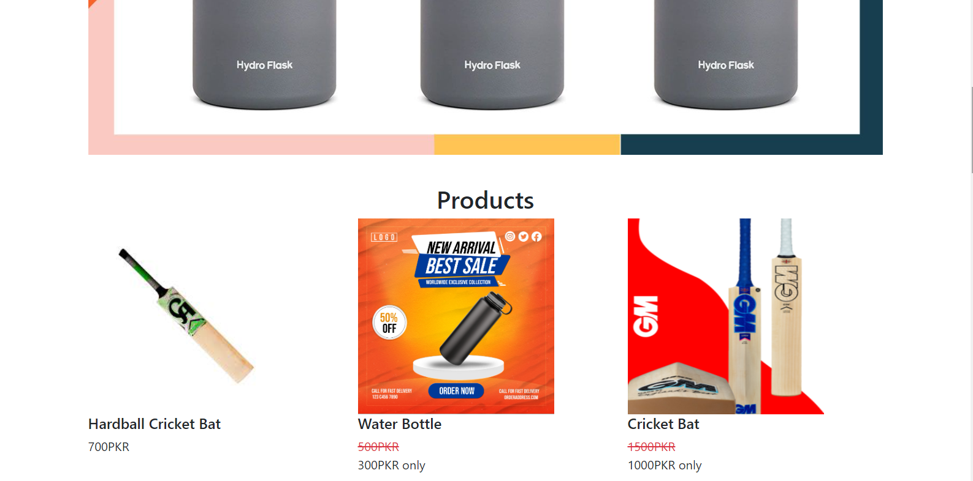

1. **Contact Page:**

In this page users can get in touch with us.

They can leave their comment.

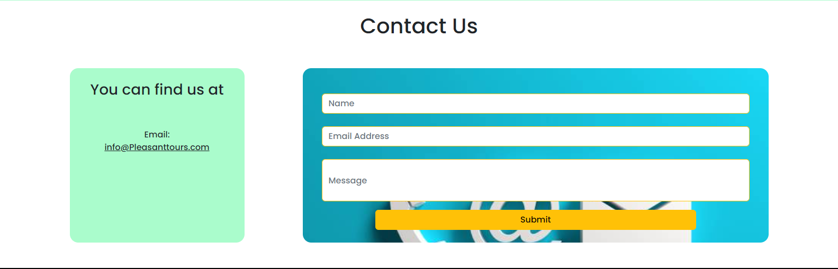

1. **Login/Register:**

In this page first user can Register their-selves, and then login.

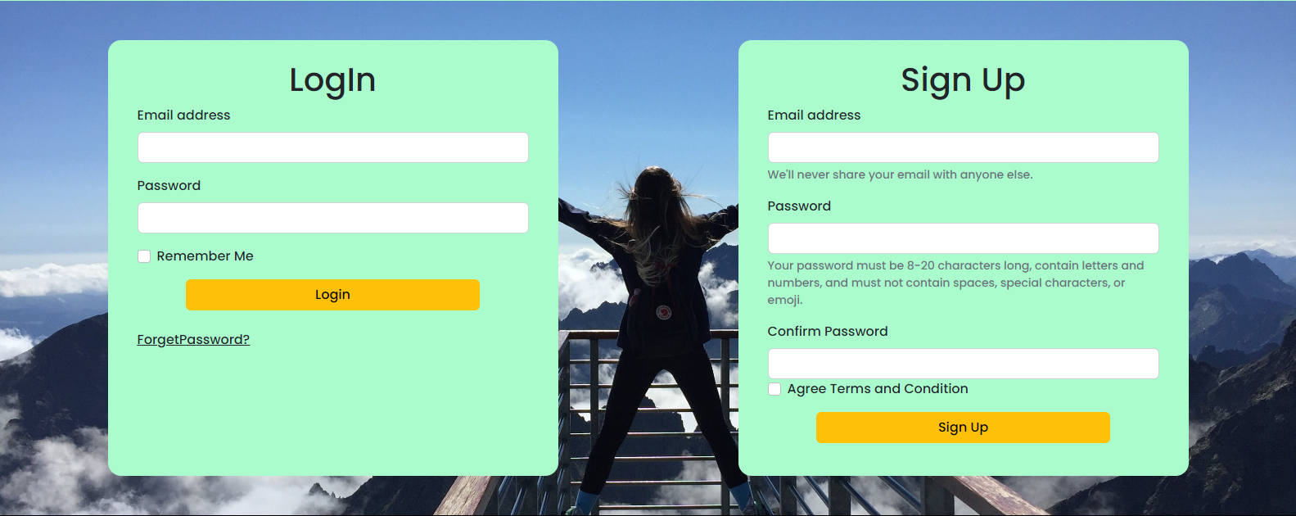

1. **Footer:**

This is the Bottom of the page.

It has some links like Shop Page, Contact Page, Login/Sign Up.

And contains our location

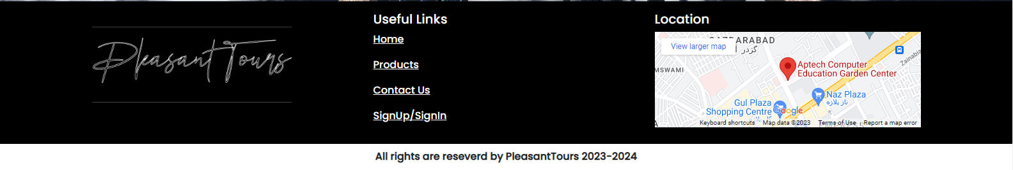

**Thank You For Reading The Documentation**